**A Web Application Door Lock Control System using Nodemcu ESP8266 and**

**RFID Technology**

A Capstone Project Proposal

Presented to the Faculty of the

Information and Communications Technology Program

STI College Alabang

In Partial Fulfilment

of the Requirements for the Degree

Bachelor of Science in Information Technology

John Lienard C. Diaz

Sofia A. Hiwatig

Joshuel Mari A. Ilagan

Camille C. San Jose

May 2022

EXECUTIVE SUMMARY

This capstone project entitled A Web Application Door Lock Control System using Nodemcu ESP8266 and RFID Technology is a door lock system that provides security with a door lock that uses a Radio Frequency Identification as a key to enter a room or property. The RFID tags are small transponders that wirelessly transmit a serial number or other identifier in response to reader queries.For this thesis, the ID of the students and staff will serve as their RFID tags that they will use to enter the Audio Visual Room. There will also be a web application wherein the admin can schedule an event for certain date and time, furthermore, the admin can also specify who are allowed and not allowed to enter the room in a specific date and time. The web application will also monitor the time in and out of the students whenever they use their Radio frequency identification to enter the room or facility to serve as additional information that can serve as security whenever accidents and problems will be encountered after or during the event. The admin can also export the user log through excel furthermore they can also specify specific dates and time that they want to export.

# APPROVAL SHEET

This capstone project proposal titled: A Web Application Door Lock Control System using Nodemcu ESP8266 and RFID Technology prepared and submitted by John Lienard C. Diaz, Sofia A. Hiwatig, Joshuel Mari A. Ilagan, and Camille C. San Jose, in partial fulfillment of the requirements for the degree of Bachelor of Science in Information Technology, has been examined and is recommended for acceptance and approval.

Mr. Jerome G. Austria

Capstone Project Adviser

Accepted and approved by the Capstone Project Review Panel

in partial fulfillment of the requirements for the degree of

Bachelor of Science in Information Technology

No description available.

|  |  |
| --- | --- |
| Mr. Jason A. Sespeñe | Ms. Janine S. Lavada |
| Panel Member | Panel Member |



Mr. John Kristopher B. Adan

Lead Panelist

Noted:

|  |  |
| --- | --- |
| Mr. Jason A. Sespeñe | Mr. Jerome G. Austria |
| Capstone Project Coordinator | Program Coordinator |

May 2022

# Table of Contents

|  |  |  |
| --- | --- | --- |
|  | | Page |
| Title Page | | i |
| Executive Summary | | ii |
| Approval Sheet | | iii |
| Acknowledgment | | iv |
| Table of Contents | | v |
| List of Figures | | vi |
| List of Tables | | vii |
| List of Notations | | viii |
| Introduction | | 1 |
|  | Project Context | 1 - 3 |
|  | Purpose and Description of the Project | 3 |
|  | Objectives of the Study | 4 |
|  | Scope and Limitations of the Study | 5 - 6 |
| Review of Related Literature/Systems | | 7 |
|  | Review of Related Literature | 7 - 8 |
|  | Related Studies and/or Systems  Synthesis | 9 - 12  12 - 13 |
| Technical Background | | 14 |
|  | Overview of Current Technologies to be Used in the System | 14 - 19 |
|  | Calendar of Activities | 19 - 20 |
|  | Resources | 21 |
| Appendix | |  |
|  | References | 22 - 24 |
|  | Resource Persons |  |
|  | Personal Technical Vitae (one page per member) | 25 - 28 |
|  | |  |

LIST OF FIGURES

Figure 1. Entity Relationship Diagram

Yes

Figure 2. System Flowchart

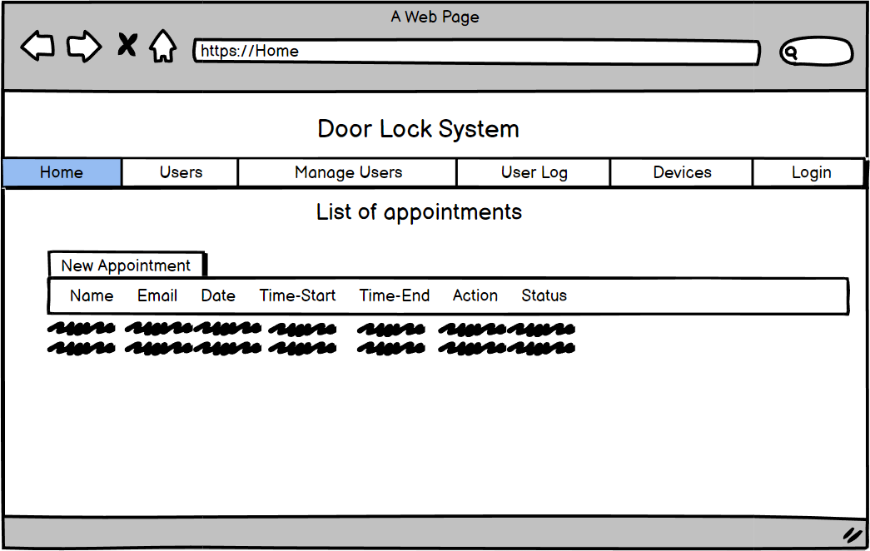

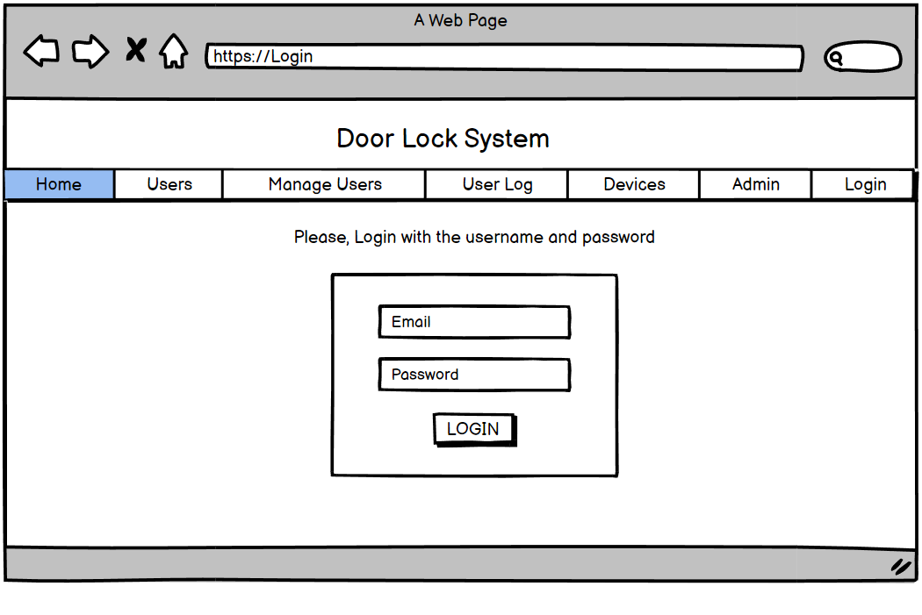Figure 3. Home Module

Figure 3.1 Login Module

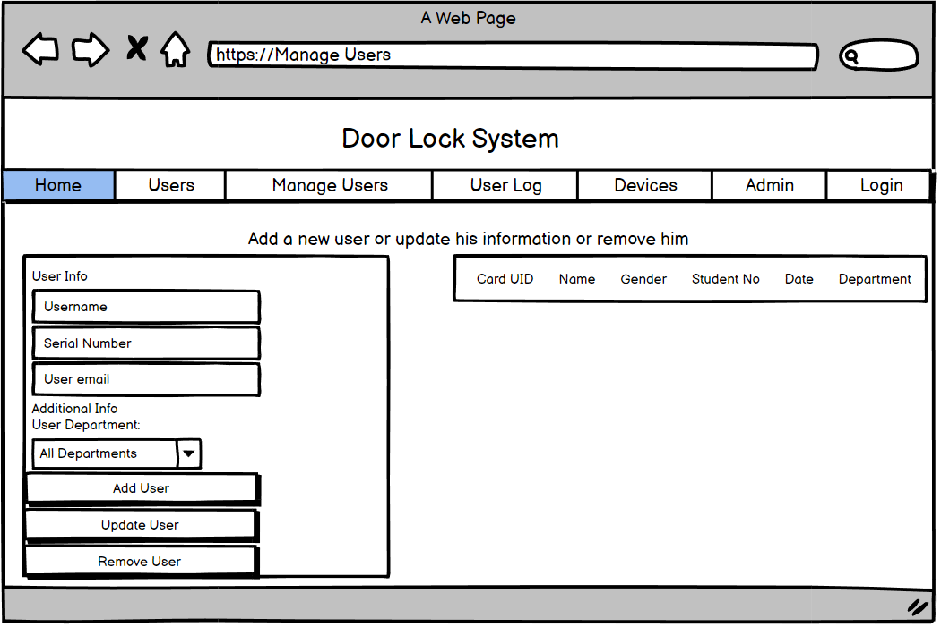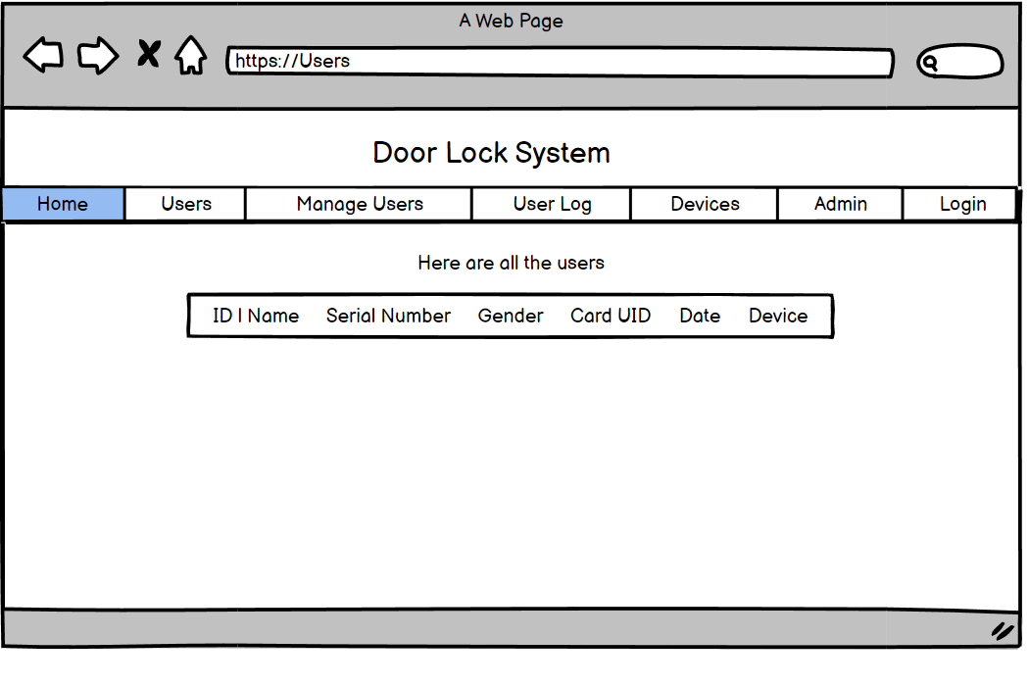Figure 3.2 User Module

Figure 3.3 Manage Users Module

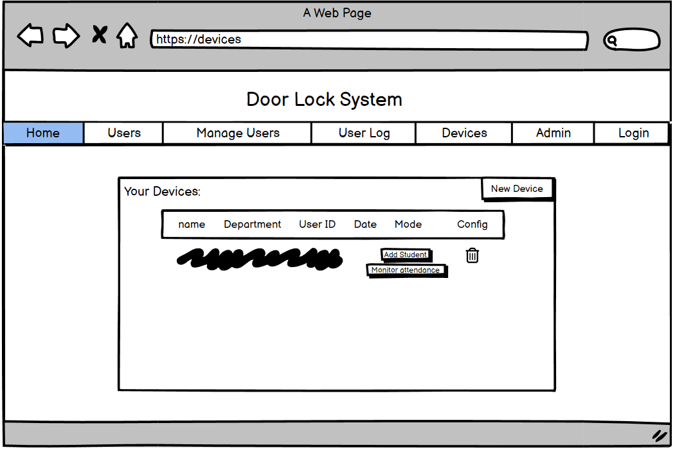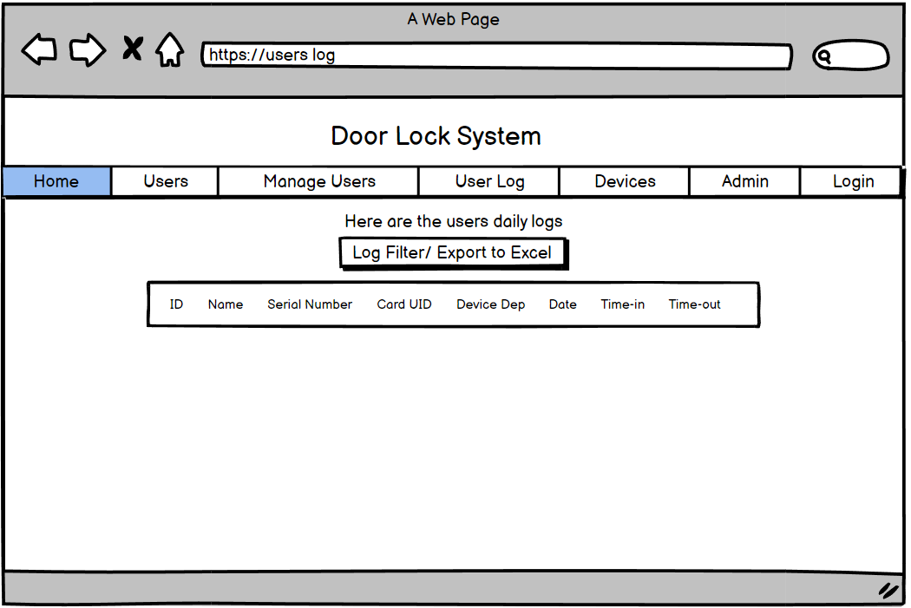Figure 3.4 User Log Module

Figure 3.5 Devices Module

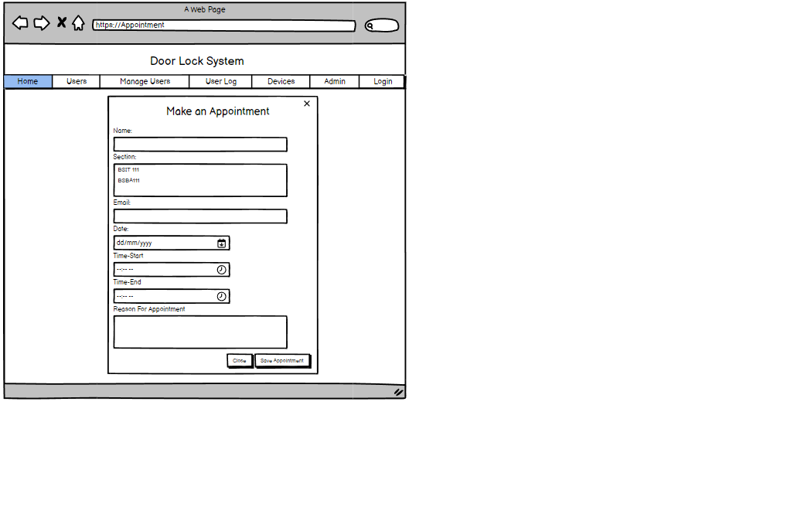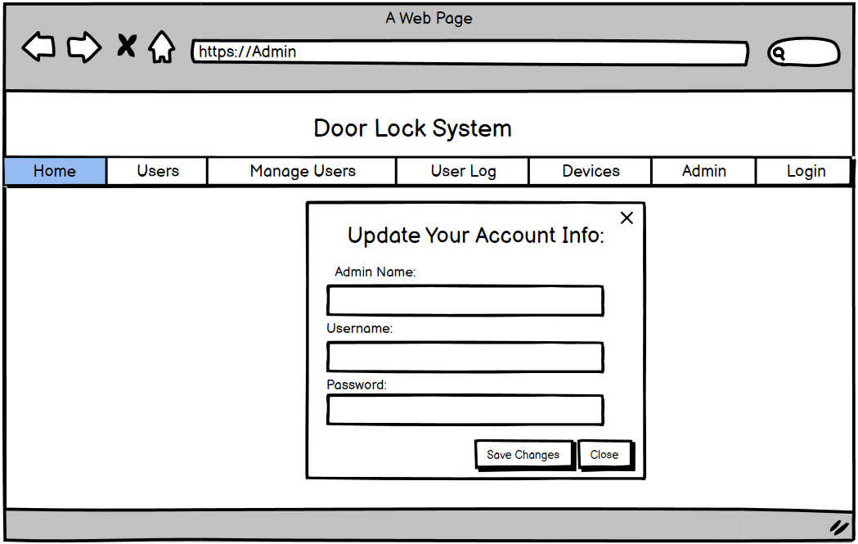Figure 3.6 Admin Module

Figure 3.7 New Appointment Module

LIST OF TABLES

Data Dictionary – is a collection of information that contains name, definitions, and attributes about data elements that are being used or captured in a database, information system, or part of a research project.

## Table 1. Data Dictionary - admin

|  |  |  |
| --- | --- | --- |
| Column | Type | Comment |
| id | int | Unique ID of admin table |
| admin_name | varchar(30) | Admin’s name |
| admin_email | varchar(80) | Admin’s email |
| admin_pwd | longtext | Admin’s password |

## Table 2. Data Dictionary – appointedsection

|  |  |  |
| --- | --- | --- |
| Column | Type | Comment |
| appointmentId | int(11) | Unique ID of the appointment |
| sectionID | int(11) | Unique ID of the section |

## Table 3. Data Dictionary – appointment_tbl

|  |  |  |
| --- | --- | --- |
| Column | Type | Comment |
| appointmentId | int(11) | Unique ID of the appointment |
| name | varchar(50) | Name of appointee |
| email | varchar(50) | School email of the appointee |
| date | date | Date of the Appointment |
| time | time | Time of the Appointment |
| reason | text | Reason of the Appointment |
| isActive | int(1) |  |

## Table 4. Data Dictionary – devices

|  |  |  |
| --- | --- | --- |
| Column | Type | Comment |
| id | int | Unique ID of the Devices |
| device_name | varchar(50) | Name of the device |
| device_dep | varchar(20) | Name of the device room |
| device_uid | text | Unique Identifier of the room |
| device_date | date | Date of the device modified |
| device_mode | tinyint(1) | The mode of the device |

## Table 5. Data Dictionary – schoolyr_tbl

|  |  |  |
| --- | --- | --- |
| Column | Type | Comment |
| schoolyear_ID | int(11) | Unique ID of the school year |
| term | varchar(50) | Term of School Year |
| isActive | int(1) |  |

## Table 6. Data Dictionary – section_tbl

|  |  |  |
| --- | --- | --- |
| Column | Type | Comment |
| sectionID | int(11) | Unique ID of the section |
| schoolyear_ID | int(11) | Unique ID of the school year |
| sectionName | varchar(50) | Name of the section |
| isActive | int(1) |  |

## Table 7. Data Dictionary – users

|  |  |  |
| --- | --- | --- |
| Column | Type | Comment |
| id | int | Unique ID of user |
| username | varchar(30) | Username of the user |
| serialnumber | double | Serial number of the user |
| gender | varchar(10) | Gender of the user |
| email | varchar(50) | Email of the user |
| card_uid | varchar(30) | Unique Identifier of the RFID tag of the user |
| card_select | tinyint | Selecting of the RFID tag of the user |
| user_date | date | The date wherein the user is added |
| device_uid | varchar(20) | Unique Identifier of the device |
| device_dep | varchar(20) | Name of the device room |
| add_card | tinyint | Addition of RFID tags of the user |

## Table 8. Data Dictionary – user_logs

|  |  |  |
| --- | --- | --- |
| Column | Type | Comment |
| id | int | Unique ID of the user |
| username | varchar(100) | Username of the user |
| serialnumber | double | Serial number of the user |
| card_uid | varchar(30) | Unique Identifier of the RFID Tag |
| device_uid | varchar(20) | Unique Identifier of the device |
| device_dep | varchar(20) | Unique Identifier of the device room |
| checkindate | date | The check in date of the card |
| timein | time | The time in of the user wherein the RFID tag is used |
| timeout | time | The time out of the user wherein the RFID tag is used |
| card_out | tinyint(1) |  |

# Introduction

## Project Context

## In our daily lives, safety is a major concern. Every person requires a sense of safety. Our security pattern includes an access control system for doors. Traditional locks are no longer as secure as they once were; anyone can gain access by breaking these locks. We need to create a system that will assist 24 hours a day, seven days a week.

A smart home system can be categorized into at least one type based on its functionality: health care, entertainment, energy, and/or security (T.D.P. Mendes, 2015). An electronic lock is a secure device which operates through electric current. Recently, keyless electronic door locks have become one of the most popular security systems that are being installed in many residents and business places as well as the classroom university.

The key characteristic behind such system lies on the reliability in which the authorized individuals can obtain permission to access the doors throughout a secure system that has an interactive interface password such as using fingerprint or using designated password to enter it (Sayidul Morsalin, 2016). Security vulnerability is caused by the keys of mechanical door lock often lost, copied, or stolen. To overcome the problem, keyless door lock systems have been introduced but the technology also has several security issues, for instance, an intruder can copy the access code or password to access the door. In addition, existing systems that utilize Radio Frequency Identification (RFID) technology are costly and complex (Boschen, 2016).

Traditional bar-coding technology is a cost-effective solution for Automatic Identification Data Collection (AIDC) applications in the industry. However, one major limitation of Radio Frequency Identification Technology is that each barcoded item must be scanned individually, limiting scanning speed. The use of manual labor or the automation of the canning process incurs additional costs. When scanning is done manually, there is also the possibility of human error. Because of these limitations, RFID technology has made inroads into AIDC applications. RFID provides greater flexibility, larger data storage capacities, higher data collection throughput, and greater data collection immediacy and accuracy (SATO America Corporation, n.d.).

The RFID tags are small transponders that wirelessly transmit a serial number or other identifier in response to reader queries. RFID tags were initially designed to eventually replace barcodes in supply chains. Their advantages include the ability to read them wirelessly and without a line of sight, the ability to store more information than barcodes, and the fact that they are more robust (Christoph Jechlitschek, 2006).

An RFID tag is made up of an integrated circuit (IC) that is embedded in a thin film medium. The antenna circuit embedded in the RFID inlay transmits information stored in the RFID chip's memory to an RFID reader via radio frequencies. The RFID tag's performance characteristics will then be determined by factors such as the type of IC used, read/write capability, radio frequency, power settings, environment, and so on. The read/write characteristics of an RFID chip define the information stored in it. The information stored in a read-only tag must be recorded during the manufacturing process and cannot typically be modified or erased. The data stored is typically a unique serial number that is used as a reference to look up more information about a specific item in a host system database. Read-only tags, like a car's "license plate," are thus useful for identifying an object (SAC, n.d.).

This circuit "NodeMCU" is the best way to quickly develop an IoT application with fewer Integrated circuits to add. It is an open-source firmware and development kit that can be used to create a proper IoT product with just a few script lines. The module is primarily based on the ESP8266, a low-cost Wi-Fi microchip that includes a full TCP/IP stack as well as microcontroller capability. Espressif Systems is the company that introduced it. This module includes a built-in USB connector as well as a wide range of pin-outs. You can easily connect the NodeMCU devkit to your laptop and flash it using a micro USB cable (Al Dahoud & Fezari, 2018).

The door lock control system will be controlled by a web application that has multiple modules where the administrator can login, a module where the administrator can choose who can and cannot access the door lock, and a module that can store information about the RFID user and when they used the RFID. Furthermore, students and faculty can schedule an appointment in a specified room, which is Audio Visual Room (AVR). As previously stated, Radio Frequency Identification (RFID) and the Nodemcu ESP8266 will be used to construct the door lock control system.

## Purpose and Description of the Project

The purpose of this project is to develop a Web-based door lock system that can be accessed with the use of Radio Frequency Identification and can be controlled through a web application that intends to offer high security, easy access, and control. This project will also present a thorough explanation and presentation regarding the use Radio Frequency Identification (RFID) that helps to enhance the lock mechanism by connecting it to the internet, making it more secured, relevant, and innovative.

This Web-based door lock system will consist of a Web application that is able to control whether the Radio Frequency Identification of the students and faculty can be used to access the Audio Visual Room since the web application also consist of an appointment module wherein students are required to ask for appointment that the admin will verify. Those are the qualities that make this unique and up to date especially now that time is progressing and most of the things in our time are based on internet and technology.

## Objectives of the Study

General Objectives

The aim of implementing a Smart Door Lock by using a web application is to open the door through commands given to the electronic devices connected to this door, via web, which solves the security issues related to locking and unlocking a door. Our objectives are to present a smart door locking system that is simple and easy to use, with high accuracy and fewer errors, and more secure.

Specific Objectives

* **To develop a module that can read RFID to access the door lock system.**  
  The users should be able to access the door lock with the use of the Radio Frequency Identification tag.
* To create a module that can provide advance and faster accessible security with ease of use for rooms.

The admin can supervise who can access and enter the room with the help of advanced technology.

* To develop a module that stores the information of RFID that is used.

The admin can register and modify each unique code and information about the RFID tag and its owner.

* **To develop a module that only the admin can login.**  
  The admin can login using their username and password.
* **To develop a module that controls who can access the door lock.**  
  The admin is able to control who is allowed to access the specific room.
* **To develop a module that can store appointments for upcoming events.**

The admin can put information and verify appointments given by the appointees.

## Scope and Limitations of the Study

The general purpose of this project is to develop a Web-based door lock system that intends to offer high security, easy access, and control. Students of STI College Alabang can enter the Audio Visual Room (AVR) with their Radio Frequency Identification (RFID), and the admin have control over who can enter the AVR with the use of a web application connected to the door lock system.

Scope

* **Login Module**

In this module, the admin is expected to enter their username and password to have access to the controller and database.

* **Users Module**

In this module, the list of all users will be displayed.

* **Manage Users Module**

In this module, the admin can add new users, including their card UID, name, gender, student number, date, and room. Futhermore, admin can modify or remove existing users.

* **Users Log Module**

In this module, the daily logs of the users are displayed, including their ID, name, serial number, card UID, room, time-in, and time-out.

* Devices Module

In this module, the admin can add, update, remove, enable, or disable a device.

* Appointment Module

In this module, the admin can add and verify appointment for upcoming events.

* Admin Module

In this module, the admin can update the admin's name, e-mail, and password.

* Logout Module

In this module, the admin exits the web application.

Limitations

* This project will use RFID technology.
* The researchers will make a web application that is connected to the Nodemcu ESP8266 Door Lock System that has control and can be accessed by the admin.
* This project can be affected by the internet connection due to the available development board being a WiFi module.
* This project will be controlled using Nodemcu ESP8266 which is a microcontroller and a cheaper version of Arduino.
* The battery used to operate the door lock is rechargeable.
* The door lock can be accessed when connected to a router.
* The faculty events does not have door lock restrictions.

# review of related literature/systems

## Review of Related Literature

An Intelligent Lock System

One of the most pressing challenges confronting any nation or corporate organization is the security of human life and property. Security systems are required everywhere, especially in banks, homes, and offices. Intelligent security systems have been developed and implemented to prevent illegal invasion as technology evolves by the second. A standard intelligent lock system should include the following basic features: (1) Provides environmental monitoring, access control, and management system. (2) Prevents unauthorized access. (3) Enables the use of a proximity card, keypad, or web interface to open doors. (4) Allows sensors to monitor temperature, humidity, smoke, the presence of water or liquids, and so on. (5) Generates an audio alert automatically. (6) Keeps track of all the security information you need every time the door is opened, including who, where, and when (Anaza, Jiya, & Haruna, 2017).

Since we are living now in the technology era, our doors should keep up with it. Having traditional doors that use keys and chain locks at home is no longer safe compared to before since intruders are now more efficient. So, building a door lock system that can be authenticated with a wireless key, like RFID, and with the help of any application that can control who can access and prevents someone from entering. So, even when users are away from their homes, they can still monitor their homes and will be notified if there will be intruders.

Radio Frequency Identification (RFID)

The use of radio frequency identification (RFID) has become ingrained in our daily lives, increasing productivity and convenience. It's a word for short-range radio technology that transmits mostly digital data between a fixed point and a moving device, or between moving objects. The modulated backscatter technique is used in this RFID system to send data from the tag to the reader. In general, the tag receives data from its internal memory and alters the loading on the tag antenna in a programmed fashion to correlate with the data. RFID is a technology that covers systems engineering, software development, encryption, and more; therefore, many engineers are involved in its development and implementation, and the industry's growth is currently hampered by a dearth of technical and business employees skilled in RFID (Juels, 2006).

Radio Frequency Identification (RFID) tags will be used as the key to the proposed door lock system. Every RFID tag has a unique code, and when the scanner reads it, the web application registers it, and the admin can modify the data of the RFID tag owner. As a result, every owner's RFID tag will also serve as their user identification.

NodeMCU

NodeMCU is a free and open platform. Its hardware design is editable, modifiable, and buildable. An ESP8266 Wi-Fi-enabled chip is used in the NodeMCU Dev Kit or board. The Espressif Systems ESP8266 is a low-cost Wi-Fi chip with TCP/IP protocol that is a highly integrated chip designed for the needs of the new connected world. It provides a complete and self-contained Wi-Fi networking solution, with the ability to host the application or offload all Wi-Fi networking functions from another application processor. The ESP8266 NodeMCU has powerful onboard processing and storage capabilities, allowing it to be integrated with sensor-specific devices via its General-Purpose Inputs or Outputs (GPIO) with minimal development and loading during runtime (Parihar, 2021).

With the proposed door lock system, the researchers will use the Radio Frequency Identification Technology as the key and the Nodemcu ESP8266 as the scanner. This system will program the Nodemcu ESP8266 for it to become the RFID reader. This device will be the main component of the hardware in the system, and it will be connected to a web application that will control it

## Related Studies and/or Systems

Local Studies and/or Systems

Development of an RFID Based Door Access System

This study is focused on using RFID for security purposes of the people entering and exiting Muntinlupa City Technical Institute. Furthermore, it is made to restrict unauthorized individual from entering the premises of Muntinlupa City Technical Institute. The purpose of this research is to monitor individuals who is entering and leaving the premises in real time manner and that gives reliability at low cost.

This enables the researchers to broaden their knowledge regarding on how to execute or implement the door lock using Radio-Frequency Identification tags. This study is also similar to the researcher’s system which helps the researcher’s to know how to do it efficiently since it also monitor individuals who enters and leave a certain facility. Moreover it also gives the reaserchers more ideas regarding the implementation of restricting unauthorized individuals.

Automated Door Lock System

This study is intent to give an intelligent and effective access control system to the Computer Laboratories in Leyte Normal University through an Automated Door Access- Control Mechanism in LNU Computer Laboratories. Moreover, this study seeks to provide a better knowledge to the school authorities regarding security and helps with monitoring on who enters and leaves computer laboratories. This system also offers convenience for it is an automated access. The door lock also has double security wherein after using an RFID tag you are required to tap in your pin to verify how authentic the user is. Furthermore, it uses a battery for source of power and there are light indicators that lets the user know the status of the backup battery.

This study is similar to the researchers project which also uses a Radio-Frequency Identification tags to have access or enter a ceratin facility. There are also several things that this study have that is similar to the researchers project. For example, this study uses battery as a source of power just like the researcher’s door lock system. Therefore this study will really be able to help the researchers to implement the system and give more ideas regarding other functions like the light indicator for the batteries which can serve as another module for the system.

Security Access Control System for College of Engineering Laboratories

This study is a RFID-based Door Lock System that shows data in a feed that includes securing a room with authentication using identification card. This study also authorize faculty personnel the admittance to a room as per schedule affirms to have a more secured room for the safekeeping of the laboratory equipments.

This study helps the researchers to gather more ideas regarding on what modules or other functions that they may add to their system such as the authorizing faculty personnel the admittance to a room as per schedule affirms. There are similarities from the researchers Door Lock System but there are also differences when it comes to different fucntions and modules. There are different ideas from different studies that can be used for the improvement of the researchers project.

Foreign Studies and/or Systems

A Smart Door Security-Based Home Automation System: An Internet of Things

In this study, a smart door security-based home automation system is developed, with smart embedded sensors and alarm systems used to protect the device facilities in the home automation for authentication or authorization, as well as user management over the network. Wireless technology, on the other hand, was used for controlling and monitoring home entrance, user authentication, authorization, and smart device management (such as GSM, ultrasonic sensor, and Bluetooth low-power enable). An Android mobile application was also created and integrated with the system to allow home users to control the system remotely. This developed system was outfitted with strict access control and password security features in the event of an intruder denial or violation, as well as to keep neighbors aware of potential human attacks. This home automation door security control provides multifaceted levels of user authentication on both hardware system development and android mobile Apps for system resourcefulness, privacy, and trustworthiness of home users or administrators (Lukman, Kolo, Mikail, & Adedokun, 2018).

This study enables the developers to broaden their knowledge regarding what other technologies they can use to control and access their door lock system. This study uses a sensor, multi ways to control the system, and an alert or notification that gives extra security for the users. For example, a text message is sent to the user's phone number when an intruder tries to enter the user's house.

Smart and Real-time Door Lock System for an Elderly User based on Face Recognition

There have been numerous sophisticated smart door lock systems developed. Nonetheless, the majority of them required the user to use an additional device such as a smartphone, tag, smartcard, or access some user interfaces, which were difficult for inexperienced elderly to use. This condition creates a barrier between the elderly and technology, making it difficult for the elderly to accept and use it. We proposed a smart and real-time door lock system for an elderly user based on a local binary pattern histogram as a face recognition algorithm with a modular system architecture design in this study. The novelty in our proposed system design is that it does not require any additional device, has no user interface, and requires the least amount of user participation by automating the processes. All the user must do is walk up to the door and stand in front of it, and the door will automatically unlock and lock after the user enters the house and closes it. The system achieved 98 percent accuracy with an average processing time of 1.449 seconds for the entire process. Furthermore, the system is designed with a modular approach, making it flexible and scalable for future development (Saputra, & Surantha, 2021).

The researcher's Door Lock Control System has its similarity with the door lock system wherein it is also considerate to all types of users like the elders that uses face reconition to unlock their door locks but when it comes to the researcher's system instead of face reconition, the users will use a RFID technology. As said in the system keys can be stolen but not our identity therefore it helps and gives researchers different ideas to improve their security to ensure a high security.

Fingerprint Door Lock System with Temperature Sensor

In this study, an advanced security system is intended for door locking. Keys can be stolen but not our identity. Furthermore, overriding a fingerprint sensor door lock is extremely difficult, so the system ensures high security. Technology is being upgraded daily and is now available to any educated and technical person with a basic understanding of computing. Now, technology is nothing more than the advancement of a specific field of science, regardless of whether it is related to computers or not. With the advancement of technology, our security is under constant threat. To address this issue, the researcher created this security system that is entirely based on biometric authentication. The researchers will use the Arduino UNO, a fingerprint sensor, a servo motor, and other hardware devices to carry out this project. Along with the operation of this fingerprint-based system are the benefits society can benefit from during this epidemic (Poddar, 2021).

This study is quite similar to the researchers' project because it also uses a keyless type door lock system, but the only difference is that it uses the fingerprint of the users as the key to access the system and the Arduino, while the proposed system will be using NodeMCU and RFID technology to carry out the project. This system also comes with a temperature sensor that is relevant due to COVID-19.

## Synthesis

Looking back through the different literature, studies, and systems conducted by different developers, it is clear that having a door lock system that uses technology is more effective than having a traditional door that uses metal keys and multiple locks. The new type of door lock system that uses fingerprint, facial recognition, RFID, NFC technology, and more has more security because this kind of technology can be connected to the Internet, which will give the users feel more safe and secure. The advantage of this technology and having a connection is even when they are not in their homes, users can still monitor and check their homes.

And the gathered different literature, studies, and systems also gave insights and knowledge on the system's structure and how it works. It also gave the researchers more ideas and features to consider to enhance the system in the future.

## TECHNICAL BACKGROUND

## Overview of Current Technologies to be Used in the System

In relevance to the current trends several places especially hotels use RFID or Radio-frequency identification tags to identify, track, and communicate with items and people. Therefore, the researchers decided to use this current trend for security purposes. The researchers made a door lock system that is connected to Nodemcu ESP8266 and uses a RFID tag that is registered in the system to have access to the door.

The web application will display the list of users that will access the door lock and enables the admin to add and delete users. Furthermore, it can also control the door lock whether it is allowed to be accessed or not.

All of these can be possible with the use of Atom as the Integrated Development Environment (IDE), and HTML, CSS, JavaScript, and PHP as the programming languages, with MySQL, XAMPP, and phpMyAdmin.

Atom

GitHub created Atom, a free and open-source text and source code editor (Atom – A Hackable Text and Source Code Editor for Linux). Its creators describe it as a "hackable text editor for the twenty-first century" (Atom 1.0). Atom allows users to install third-party packages and themes to customize the editor's features and appearance, allowing you to set it up according to your preferences and with ease (Atom). It is as welcoming to a new developer as it is to an experienced one.

But what makes Atom so great for data science is that it allows you to work consistently with R and Python. Furthermore, Atom's default packages support syntax highlighting for the following programming languages and file formats: C, C++, C#, COBOL, CSS, CoffeeScript, Go, HTML, Java, JavaScript, JSON, Perl, PHP, Ruby, Scala, SQL, and many more (Atom).

HTML Language

HTML, or HyperText Markup Language, is the standard markup language for documents intended to be displayed in a web browser. Technologies like Cascading Style Sheets (CSS) and scripting languages like JavaScript can help. Web browsers receive HTML documents from a web server or local storage and convert them to multimedia web pages. HTML elements are the building blocks of HTML pages. HTML elements describe the structure of a web page semantically and originally included cues for the appearance of the document. Images and other objects, such as interactive forms, can be embedded into the rendered page using HTML constructs. HTML allows you to create structured documents by denoting structural semantics for text elements like headings, paragraphs, lists, links, quotes, and so on. Tags, which are written in angle brackets, delineate HTML elements.

HTML is used to structure a web page and its content; it can be structured in paragraphs.

CSS Mark Up Language

CSS is a style sheet language used to describe the presentation of a document written in a markup language such as HTML. CSS, like HTML and JavaScript, is a foundational technology of the World Wide Web. CSS is intended to separate presentation and content, including layout, colors, and fonts. This separation can improve content accessibility; provide more flexibility and control in the specification of presentation characteristics; allow multiple web pages to share formatting by specifying the relevant CSS in a separate.css file, reducing complexity and repetition in structural content; and allow the.css file to be cached to improve page load speed between the pages that share the file and its formatting. The separation of formatting and content also allows the same markup page to be presented in different styles for different rendering methods, such as on-screen, in print, by voice (via speech-based browser or screen reader), and on Braille-based tactile devices. CSS also includes rules for alternate formatting when viewing content on a mobile device.

CSS is used to style and layout web pages by changing the font, color, size, and spacing of content that is divided into multiple columns.

JavaScript Language

JavaScript is a dynamic programming language for computers. It is lightweight and is most commonly used as a component of web pages, where implementations enable the client-side script to interact with the user and create dynamic pages. It is an object-oriented programming language that can be interpreted.

JavaScript was originally known as LiveScript, but Netscape changed its name to JavaScript, possibly due to the buzz generated by Java. JavaScript first appeared in Netscape 2.0 in 1995 under the name LiveScript. The language's general-purpose core is embedded in Netscape, Internet Explorer, and other web browsers.

PHP Programming Language

PHP, which stands for "PHP: Hypertext Preprocessor," is a widely used, open-source scripting language that is free to download and use. The scripts are run by the server.

PHP is capable of generating dynamic page content. It is capable of creating, opening, reading, writing, deleting, and closing files on the server. It can also collect form data, send and receive cookies, add, delete, and modify data in your database, control user access, and encrypt data.

PHP allows you to do more than just generate HTML. Images, PDF files, and even Flash movies can be output. You can also output any type of text, including XHTML and XML.

MySQL

MySQL is a relational database management system (RDBMS) based on a structured query language that is free and open-source (SQL). MySQL runs on all major platforms, including Windows, Linux, and Solaris. It is free to use for individuals and non-production environments under the GNU General Public License; however, a commercial license is required if used commercially.

MySQL, like other relational databases, stores information in the form of tables, columns, and rows. A unique identifier is assigned to each entry. Its raison d'être has always been database performance and reliability. MySQL was created and optimized for use in web development; it is arguably the most widely used database in web server deployments. MySQL works well with Apache and PHP and is frequently used in LAMP stack deployments. MySQL is the database of choice for Facebook, Twitter, and Wikipedia, and it powers 9 out of 10 websites on the internet today.

Xampp

XAMPP is an acronym that stands for Cross-Platform, Apache, MySQL, and PHP and Perl. It is an open-source web solution package that includes Apache distribution for many servers and command-line executables, as well as modules such as Apache server, MariaDB, PHP, and Perl.

Before releasing a website or client to the main server, a local host or server can use XAMPP to test it on computers and laptops. It is a platform that provides a suitable environment for testing and verifying the operation of projects based on Apache, Perl, MySQL databases, and PHP via the host's system. Perl is a web development programming language, PHP is a backend scripting language, and MariaDB is the most widely used database developed by MySQL.

phpMyAdmin

phpMyAdmin is a PHP-based open-source software tool that was released on September 9, 1998. It is essentially a third-party tool for managing the tables and data within the database. phpMyAdmin can perform a variety of operations on MariaDB and MySQL. The primary function of phpMyAdmin is to handle MySQL administration over the web.

It is the most widely used application for managing MySQL databases. Using this software, we can create, update, drop, alter, delete, import, and export MySQL database tables. phpMyAdmin also supports a wide range of operations on MySQL and MariaDB, such as managing databases, relations, tables, columns, indexes, permissions, and users, among others. These operations can be performed through the user interface, while any SQL statement can still be executed.

phpMyAdmin is available in 72 languages and supports both RTL and LTR languages, making it accessible to a wide range of users. We can run MySQL queries, repair, optimize, and check tables, as well as perform other database management tasks. phpMyAdmin can also be used for administrative tasks like database creation and query execution.

phpMyAdmin is a graphical user interface (GUI) application for managing MySQL databases. We can create the database and tables manually and then run the query on them. It has a web interface and can run on any server. We can access it from any computer because it is web-based.

Arduino IDE

The Arduino IDE is open-source software for writing and uploading code to Arduino boards. The IDE application is compatible with a variety of operating systems, including Windows, Mac OS X, and Linux. It is compatible with the programming languages C and C++. IDE is an abbreviation for Integrated Development Environment.

Sketching refers to the process of writing a program or code in the Arduino IDE. To upload the sketch written in the Arduino IDE software, we must connect the Genuino and Arduino board to the IDE. The sketch is saved with the .ino extension.

## Calendar of Activities

**Brainstorming**

During the first to third week of March, the researchers discussed and brainstormed three projects that is relevant. For each of the project they discussed and made a plan on how to execute the said projects.

**Chapter 1**

The researchers created this chapter from the last week of March until the second week of May which includes the Project Context, Purpose and Description of the Project, Objectives of the Study, Scope and Limitations of the Study.

**Chapter 2**

The researchers created this chapter from the third week of April until the first week of May which includes the Review of Related Literature, Related Studies and/or Systems, Synthesis.

**Chapter 3**

The researchers created this chapter from the first week of May which includes the Overview of Current Technologies to be used in the system, Calendar of Activities, Resources.

**ERD/Flowchart**

The researchers created the ERD/Flowchart on the last week of May 2022.

**Chapter 4**

The researchers created this chapter from third week of October until the _____ . It includes methodology, requirements analysis, and documentation, design of software, and implementation plan.

**Chapter 5**

The researchers finished this chapter on the ____ of ____. It includes the conclusions and recommendations of the developers.

**System/Prototype**

The researchers developed the hardware from the first week of April 2022 until _____. And the researchers developed the web application from the third week of April 2022 until _____.

**Presentation**

The researchers prepared the Presentation from _________ until ________.

|  |  |  |  |  |  |  |  |  |  |  |  |  |  |  |  |  |  |  |  |  |  |  |  |  |  |  |  |  |  |  |  |  |  |  |  |  |  |  |  |  |  |  |  |  |  |  |  |  |  |  |  |  |
| --- | --- | --- | --- | --- | --- | --- | --- | --- | --- | --- | --- | --- | --- | --- | --- | --- | --- | --- | --- | --- | --- | --- | --- | --- | --- | --- | --- | --- | --- | --- | --- | --- | --- | --- | --- | --- | --- | --- | --- | --- | --- | --- | --- | --- | --- | --- | --- | --- | --- | --- | --- | --- |
| MONTH | MARCH | | | | APRIL | | | | MAY | | | | JUNE | | | | JULY | | | | AUGUST | | | | SEPTEMBER | | | | OCTOBER | | | | NOVEMBER | | | | DECEMBER | | | | JANUARY | | | | | | | | | | | |
| ACTIVITY |
| Brainstorming |  |  |  |  |  |  |  |  |  |  |  |  |  |  |  |  |  |  |  |  |  |  |  |  |  |  |  |  |  |  |  |  |  |  |  |  |  |  |  |  |  | |  | | | |  | | | | |  |
| Documentation | | | | | | | | | | | | | | | | | | | | | | | | | | | | | | | | | | | | | | | | | | | | | | | | | | | | |
| Project Context |  |  |  |  |  |  |  |  |  |  |  |  |  |  |  |  |  |  |  |  |  |  |  |  |  |  |  |  |  |  |  |  |  |  |  |  |  |  |  |  |  | |  | | | |  | | | | |  |
| Purpose and Description of the study |  |  |  |  |  |  |  |  |  |  |  |  |  |  |  |  |  |  |  |  |  |  |  |  |  |  |  |  |  |  |  |  |  |  |  |  |  |  |  |  |  | |  | | |  | | | | |  | |
| zzz Objectives of the study |  |  |  |  |  |  |  |  |  |  |  |  |  |  |  |  |  |  |  |  |  |  |  |  |  |  |  |  |  |  |  |  |  |  |  |  |  |  |  |  |  | |  | | |  | | | | |  | |
| Scope and Limitations |  |  |  |  |  |  |  |  |  |  |  |  |  |  |  |  |  |  |  |  |  |  |  |  |  |  |  |  |  |  |  |  |  |  |  |  |  |  |  |  |  | |  | |  | | | | |  | | |
| ERD, Flowcharts, and Wireframes |  |  |  |  |  |  |  |  |  |  |  |  |  |  |  |  |  |  |  |  |  |  |  |  |  |  |  |  |  |  |  |  |  |  |  |  |  |  |  |  |  |  | |  | | | | |  | | | |
| Review of Related Literature/Systems |  |  |  |  |  |  |  |  |  |  |  |  |  |  |  |  |  |  |  |  |  |  |  |  |  |  |  |  |  |  |  |  |  |  |  |  |  |  |  |  |  |  | |  | | | |  | | | | |
| Synthesis |  |  |  |  |  |  |  |  |  |  |  |  |  |  |  |  |  |  |  |  |  |  |  |  |  |  |  |  |  |  |  |  |  |  |  |  |  |  |  |  |  |  | |  | | | |  | | | | |
| Overview of Current Technologies to be  Used in the system |  |  |  |  |  |  |  |  |  |  |  |  |  |  |  |  |  |  |  |  |  |  |  |  |  |  |  |  |  |  |  |  |  |  |  |  |  |  |  |  |  |  | |  | | | |  | | | | |
| Calendar of Activities |  |  |  |  |  |  |  |  |  |  |  |  |  |  |  |  |  |  |  |  |  |  |  |  |  |  |  |  |  |  |  |  |  |  |  |  |  |  |  |  |  |  | |  | | | |  | | | | |
| Resources |  |  |  |  |  |  |  |  |  |  |  |  |  |  |  |  |  |  |  |  |  |  |  |  |  |  |  |  |  |  |  |  |  |  |  |  |  |  |  |  |  |  | |  | | | |  | | | | |
| Methodology, Results, and Discussion |  |  |  |  |  |  |  |  |  |  |  |  |  |  |  |  |  |  |  |  |  |  |  |  |  |  |  |  |  |  |  |  |  |  |  |  |  |  |  |  |  |  | |  | | | |  | | | | |
| Conclusions and Recommendations |  |  |  |  |  |  |  |  |  |  |  |  |  |  |  |  |  |  |  |  |  |  |  |  |  |  |  |  |  |  |  |  |  |  |  |  |  |  |  |  |  |  | |  | | | |  | | | | |
| Refererences |  |  |  |  |  |  |  |  |  |  |  |  |  |  |  |  |  |  |  |  |  |  |  |  |  |  |  |  |  |  |  |  |  |  |  |  |  |  |  |  |  |  | |  | | | |  | | | | |
| Personal Technical Vitae |  |  |  |  |  |  |  |  |  |  |  |  |  |  |  |  |  |  |  |  |  |  |  |  |  |  |  |  |  |  |  |  |  |  |  |  |  |  |  |  |  |  | |  | | | |  | | | | |
| Hardware | | | | | | | | | | | | | | | | | | | | | | | | | | | | | | | | | | | | | | | | | | | | | | | | | | | | |
| Buying and Ordering ff equipments |  |  |  |  |  |  |  |  |  |  |  |  |  |  |  |  |  |  |  |  |  |  |  |  |  |  |  |  |  |  |  |  |  |  |  |  |  |  |  |  |  |  | |  | | | |  | | | | |
| Assembling of hardwares |  |  |  |  |  |  |  |  |  |  |  |  |  |  |  |  |  |  |  |  |  |  |  |  |  |  |  |  |  |  |  |  |  |  |  |  |  |  |  |  |  |  | |  | | | |  | | | | |
| Web Application & Database | | | | | | | | | | | | | | | | | | | | | | | | | | | | | | | | | | | | | | | | | | | | | | | | | | | | |
| Web Application |  |  |  |  |  |  |  |  |  |  |  |  |  |  |  |  |  |  |  |  |  |  |  |  |  |  |  |  |  |  |  |  |  |  |  |  |  |  |  |  |  |  | |  | | | |  | | | | |
| Creating & Linking of Database |  |  |  |  |  |  |  |  |  |  |  |  |  |  |  |  |  |  |  |  |  |  |  |  |  |  |  |  |  |  |  |  |  |  |  |  |  |  |  |  |  |  | |  | | | |  | | | | |

**Gantt Chart of Activities**

## Resources

* Hardware
  + RC522 MFRC522 RFID Reader Module 13.56MHz
  + Solenoid Lock 12VDC for Doors
  + Nodemcu V3 ESP8266 ESP-12E WiFi development board
  + 5v 11channel relay
  + Breadboard
  + Jumpers

Recommended System Requirements

* + Processor: Intel(R) Core(TM) i5-8250U
  + Operating System: Windows 10 Home
  + Graphics Card: NVIDIA GeForce GTX 1050
  + RAM: 16GB DDR4
  + Storage: 250GB M.2 NVMe SSD, & 1TB HDD
* Software
  + Visual Studio Code

The developers used Visual Studio Code as a source-code editor to design and program the web application. Furthermore it is also used to link the database to the web application.

* + MySQL

The developers used MySQL for database management.

* + MockFlow

The developers used Mockflow for editing the wireframe of the web application.

METHODOLOGY, RESULTS, AND DISCUSSION

This chapter presents the requirements analysis and documentation, design of software and processes, development and testing, system prototype and description, implementation plan and results.

The researchers make us of Waterfall method in the development of the system. The Waterfall method contains the processes of developing and designing the web application for Door Lock Control System. The model exhibits the development of the system from requirement analysis to system maintenance.

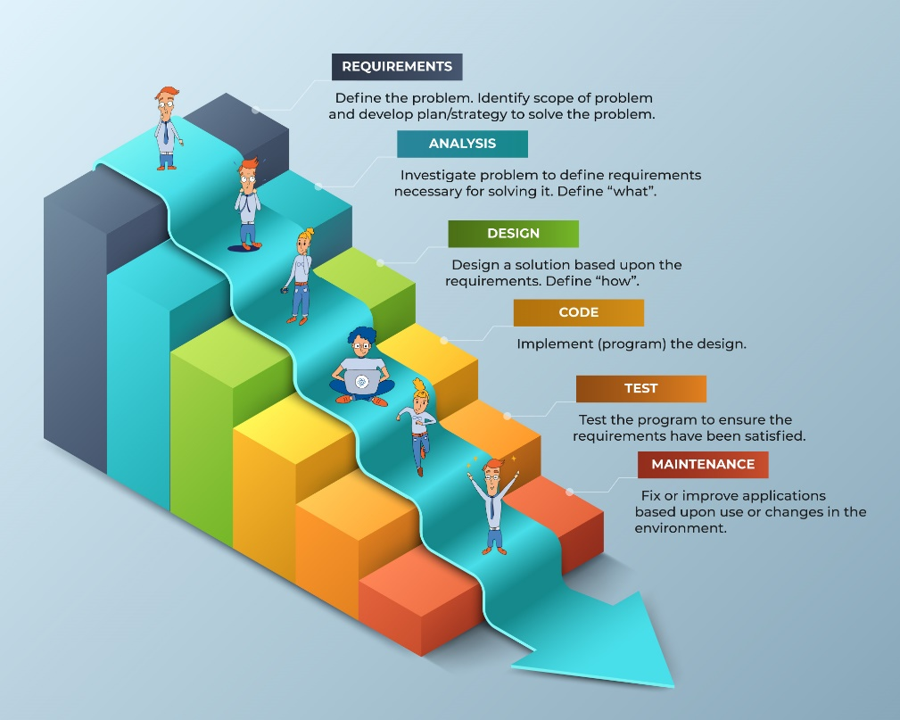

*Figure 4.1 Waterfall Methodology Diagram*

Stage 1: Requirements

This is where all the requirement needed for the system are documented and those are the functional nad non-functional requirements. During this stage, the researchers are able to identify the scope of the problem and develop a plan to solve the problem.

Stage 2: Analysis

In this stage, analysis is where the researchers investigate the problem that is defined in the requirements. This is where the action happens which is the necessary things to do to solve the problem. Furthermore, the question “what” will be defined in this stage.

Stage 3: Design

This stage is where the question “how” is defined. The researchers designs a solution upon the set out requirements which is the flowchart and ERD, as well as the project’s scope and limitation, objectives, and purpose.

Stage 4: Code

This is where the implementation happens after the design is completed. In this stage, researchers develops an application that is based on the requirements gatheres.

Stage 5: Test

After the implementation or coding, the testing takes place. Wherein the researchers will test the web application to ensure that it is working and has all the requirements that is gathered. This ensures a good user experience with the user.

Stage 6: Maintenance

After the application is released to the client, the maintenance will now begin. This is where the improvement of application based upon use and change in environment will happen.

1. Requirements Analysis

This phase depicts the requirements definition required for the development of the Web Application Door Lock Control System using Nodemcu ESP8266 and

RFID Technology.

The researchers must make the necessary preparations in order to develop the proposed system. The researchers gained an overview of what had been studied by previous researchers and developers through the review of related literatures, which provided discernment about the theories, hypotheses, and methodologies. And, with the help of early research on the topic and online articles, the researchers were able to understand the need to continue the study and its impact on dealing with current problems in this area.

The researchers present the software development tools, hardware specifications, and peopleware recommendations for the development of the Web Application Door Lock Control System using Nodemcu ESP8266 and RFID Technology.

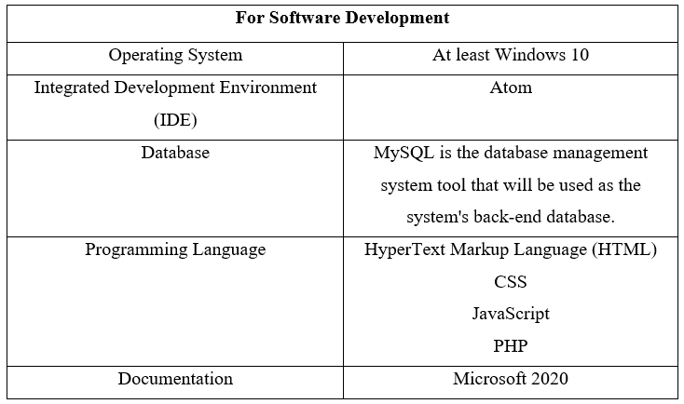

Table 4.1 Software Requirements

|  |  |
| --- | --- |
| Recommended Hardware | |
| Processor | i5 or higher |
| Memory | 8GB RAM or higher |
| Disk Storage | 500GB HDD/SSD |
| Other | Standard keyboard  USB Optical Mouse |

|  |  |
| --- | --- |
| Recommended Peopleware | |
| *Software Developers* | *Job Responsibilities* |
| Programmer | The programmer who is familiar with the Atom IDE and uses the following languages: HTML, CSS, Javascript, and PHP. He/she will be in charge of developing the system's functions, design, flow, and implementation. He/she should be familiar with MySQL in order to add, edit, delete, and manipulate data in the database. He or she should be familiar with basic troubleshooting techniques in case the system fails. |
| Designer | The designer who is familiar with the Atom IDE and who works with HTML and CSS. He/she will be able to assist the programmer in the development of the system's design. |
| *Users* | *Functions* |
| Admin (Academic Assistant) | The system will be used by the administrator to book and confirm a schedule. He/she will also be in charge of supervising and controlling students who have access to the specific schedule. In addition, he or she will be able to generate access reports. |
| Faculty Members and Students | The Faculty members and students can book a schedule on a specific room using the system as a user. |

*Table 4.3 Peopleware Recommendations*

1. Requirements Documentation

The information provided below includes all of the software features that demonstrate how the system can interact and meet the needs of users when booking a schedule and the admin when using and supervising the web application.

1. Design of Sotware, System, Product, and/or Processes

The researchers developed an Entity Relationship Diagram (ERD), a system flowchart, wireframe, and a list of all software features that must be present in the proposed system. These serve as a guide for the researchers throughout the system development process, ensuring that the developers meet all requirements and provide what the users want and need to enhance and get the most out of the system prototype's potential to increase security, convenience, and innovation.

The researchers chose Atom as the integrated development environment (IDE) and HTML, CSS, JavaScript, and PHP as the programming languages to create a door lock system with a web application. MySQL was also used as a database management system. While the developers are gradually transforming their technical solution into physical software, they sought the advice of an expert, who also serves as their thesis adviser, to ensure that everything is on track. And, to ensure that the system is truly useful and relevant for users, particularly the admin, once deployed, developers consult with their adviser during the design process, reevaluate the proposed system, and keep up with any changes made to the mobile application.

1. Development and Testing

Throughout the development process, the researchers conducted numerous tests to ensure that the system met all of the requirements. They were able to avoid potential problems and get ideas to improve the system prototype with the assistance of their thesis adviser. Module by module, the developers tested their proposed system until it was ready to be tested as a whole. The developers check and list all of the requirements that the system meets in order to monitor the system's progress and have enough time to look for and fix errors.

1. Description of Prototype
2. Implementation Plan
3. Implementation Results

# APPENDICES

REFERENCE

[1] Al Dahoud, A. & Fezari, M. (2018). NodeMCU V3 For Fast IoT Application Development. Retrieved from https://www.researchgate.net/publication/328265730_NodeMCU_V3_For_Fast_IoT_Application_Development

[2] Anaza, S.O., Jiya, J. D., & Haruna, Y. S. (2017). A Review of Intelligent Lock System. Retrieved from https://www.ajer.org/papers/v6(06)/B06060915.pdf

[3] Arcita, E. (2015). Development of an RFID Based Door Access System. Retrieved from https://pdfcoffee.com/development-of-an-rfid-based-door-access-system-pdf-free.html

[4] Atlantic.net. (n.d.) What is mysql?. Retrieved from https://www.atlantic.net/dedicated-server-hosting/what-is-mysql/

[5] Boschen, M. J. (2016). Using Qr Codes in the Classroom to Enhance Learning. Retrieved from https://www.whatihavelearnedteaching.com/: https://www.whatihavelearnedteaching.com/using-qr-codes-in-the-classroom/

[6] Christoph, J. (2006). A Survey Paper on Radio Frequency Identification (RFID) Trends. Retrieved from https://www.cse.wustl.edu/~jain/cse574-06/ftp/rfid.pdf?msclkid=1073cce8b7c811ec94770894a14d5469

[7] DataCamp. (2019). Overview of Atom IDE. Retrieved from https://www.datacamp.com/tutorial/ide-atom

[8] Decena, Q., Fernando, K., Garrido, A., Ignacio, A., Robles, I., Roque, R., et al. (2015). “Security Access Control System For College Of Engineering Laboratories”. Retrieved from https://www.academia.edu/29111299/THESIS_FINAL_FINAL

[9] Esmeralda, J. (n.d.). Automated Door Lock System. Retrieved from https://www.academia.edu/22671982/Automated_Door_Lock_System

[10] J. Landt, "The history of RFID," in IEEE Potentials, vol. 24, no. 4, pp. 8-11, Oct.-Nov. 2005, doi: 10.1109/MP.2005.1549751.

[11] JavaTPoint. (n.d.). Arduino ide. Retrieved from https://www.javatpoint.com/arduino-ide

[12] JavaTPoint. (n.d.). phpMyAdmin. Retrieved from https://www.javatpoint.com/phpmyadmin

[13] JavaTPoint. (n.d.). Xampp tutorial. Retrieved from https://www.javatpoint.com/xampp

[14] Lorenzo, B. (2017, 10). “A Robust Dynamic Edge Network Architecture for the Internet-of-Things”. Retrieved from https://www.researchgate.net/: https://www.researchgate.net/publication/327382336_Robust_Resource_Allocation_Using_Edge_Computing_for_Smart_Oil_Fields

[15] Lukman, A., Kolo, J., Mikail, O., & Adedokun, E. (2018). A Smart Door Security-Based Home Automation System: An Internet of Things. Retrieved from https://www.researchgate.net/profile/Ajao-Lukman/publication/326991167_A_Smart_Door_Security-Based_Home_Automation_System_An_Internet_of_Things/links/5b7167ec92851ca65057c30a/A-Smart-Door-Security-Based-Home-Automation-System-An-Internet-of-Things.pdf

[16] Parihar, Y. S. (2019). Internet of Things and Nodemcu: A review of use of Nodemcu ESP8266 in IoT products. Retrieved from https://www.researchgate.net/profile/Yogendra-Singh-Parihar/publication/337656615_Internet_of_Things_and_Nodemcu_A_review_of_use_of_Nodemcu_ESP8266_in_IoT_products/links/5e29767b4585150ee77b868a/Internet-of-Things-and-Nodemcu-A-review-of-use-of-Nodemcu-ESP8266-in-IoT-products.pdf

[17] Poddar, A. (2021). Fingerprint Door Lock System with Temperature Sensor. Retrieved from https://iopscience.iop.org/article/10.1088/1742-6596/1797/1/012052/pdf

[18] Ray, P. (2018, July). “A survey on Internet of Things architectures”. pp. 291-319.

[19] Saputra, R., & Surantha, N. (2021). Smart and Real-time Door Lock System for an Elderly User Based on Face Recognition. Retrieved from https://beei.org/index.php/EEI/article/view/2955/2178

[20] Sato America Corporation. (n.d.). Basics in RFID. Retrieved from https://d2n1rly8br52rx.cloudfront.net/pdfs/resources/Basics-in-RFID.pdf?mtime=20180811220720&msclkid=10749f83b7c811ec84e4d9632909954f

[21] Sayidul Morsalin, A. J. (2016, 8). ResearchGate. Retrieved from (PDF) Machine-to-machine communication based smart home security system by NFC, fingerprint, and PIR sensor with mobile android application: https://www.researchgate.net/publication/345742579_Machine-to-machine_communication_based_smart_home_security_system_by_NFC_fingerprint_and_PIR_sensor_with_mobile_android_application

[22] TutorialsPoint. (n.d.) What is javascript?. Retrieved from https://www.tutorialspoint.com/javascript/javascript_overview.htm#:~:text=JavaScript%20is%20a%20dynamic%20computer,language%20with%20object%2Doriented%20capabilities.

[23] W3Schools. (n.d.). Php Introduction. Retrieved from https://www.w3schools.com/php/php_intro.asp

Curriculum Vitae of

John Lienard C. Diaz

15 ipil ipil St. Purok 5 Lower Bicutan, Taguig City

lienarddiax@gmail.com

09195819932

EDUCATIONAL BACKGROUND

|  |  |  |
| --- | --- | --- |
| Level | Inclusive Dates | Name of school/ Institution |
| Vocational/Technical | April 2019 | Informatics Computer Institute Festival Mall |
| High School | April 2017 | Muntinlupa National HighSchool-Main |
| Elementary | March 2013 | Itass Elementary School-Annex |

PROFESSIONAL OR VOLUNTEER EXPERIENCE

|  |  |  |
| --- | --- | --- |
| Inclusive Dates | Nature of Experience/  Job Title | Name and Address of Company or Organization |
| Dec ’18-July ‘19 | HR- Assistant | Universal Head Starters Inc, |

AFFILIATIONS

|  |  |  |
| --- | --- | --- |
| Inclusive Dates | Name of Organization | Position |
| -- | -- | -- |

SKILLS

|  |  |  |
| --- | --- | --- |
| SKILLS | Level of Competency | Date Acquired |
| HTML | Intermediate | March ‘19 |
| CSS | Intermediate | March ‘19 |
| C# | Intermediate | September ‘21 |
| MS SQL | Intermediate | September ‘21 |
| SAP Business One | Professional | March ‘21 |
| Python | Beginner | October ‘20 |
| Java | Intermediate | July ‘19 |
| JavaScript | Beginner | July ‘19 |
| PHP | Intermediate | July ‘19 |

TRAININGS, SEMINARS, OR WORKSHOPS ATTENDED

|  |  |
| --- | --- |
| Inclusive Dates | Title of Training, Seminar, or Workshop |
| March ‘21 | SAP Basic (Logistics and Financials) |
| November ‘19 | Upgrade 2.0: Become a Better You |
|  |  |
|  |  |

Curriculum Vitae of

Sofia A. Hiwatig

22 Cathleya St. Purok 3, Blk 6, Bagong Paraiso,

Bayanan, Muntinlupa City

sofiahiwatigabrenica@gmail.com

09476477458

EDUCATIONAL BACKGROUND

|  |  |  |
| --- | --- | --- |
| Level | Inclusive Dates | Name of school/ Institution |
| Vocational/Technical | May 2019 | STI College Alabang |
| High School | April 2017 | Muntinlupa National Highschool |
| Elementary | March 2013 | Bayanan Elementary School Unit 1 |

PROFESSIONAL OR VOLUNTEER EXPERIENCE

|  |  |  |
| --- | --- | --- |
| Inclusive Dates | Nature of Experience/  Job Title | Name and Address of Company or Organization |
| -- | -- | -- |

AFFILIATIONS

|  |  |  |
| --- | --- | --- |
| Inclusive Dates | Name of Organization | Position |
| September 2022 | Computer Society | Treasurer |
| September 2021 | Computer Society | 3rd year Representative |
| August 2020  July 2019 | Computer Society  Computer Society | 2nd year Representative  1st year Representative |
| June 2018 | Junior Computer Society | Treasurer |
| June 2017 | Junior Computer Society | Media |

SKILLS

|  |  |  |
| --- | --- | --- |
| SKILLS | Level of Competency | Date Acquired |
| HTML | Intermediate | March ‘19 |
| CSS | Intermediate | March ‘19 |
| C# | Beginner | September ‘21 |
| MS SQL | Beginner | September ‘21 |
| SAP Business One | Professional | March ‘21 |
| Python | Beginner | October ‘20 |
| Java | Intermediate | July ‘19 |
| JavaScript | Beginner | July ‘19 |
| PHP | Beginner | July ‘19 |

TRAININGS, SEMINARS, OR WORKSHOPS ATTENDED

|  |  |
| --- | --- |
| Inclusive Dates | Title of Training, Seminar, or Workshop |
| March ‘21 | SAP Basic (Logistics and Financials) |
| November ‘19 | Upgrade 2.0: Become a Better You |
|  |  |
|  |  |

Curriculum Vitae of

Joshuel Mari A. Ilagan

339 Purok 1 Sucat Muntinlupa City

ijoshuel99@gmail.com

09305853996

EDUCATIONAL BACKGROUND

|  |  |  |
| --- | --- | --- |
| Level | Inclusive Dates | Name of school/ Institution |
| Senior High School | May 2019 | Our Lady of the Lake School |
| Junior High School | April 2017 | Our Lady of the Lake School |
| Elementary | March 2013 | Toddlers and Friends Learning Center |

PROFESSIONAL OR VOLUNTEER EXPERIENCE

|  |  |  |
| --- | --- | --- |
| Inclusive Dates | Nature of Experience/  Job Title | Name and Address of Company or Organization |
| --- | --- | --- |
|  |  |  |

AFFILIATIONS

|  |  |  |
| --- | --- | --- |
| Inclusive Dates | Name of Organization | Position |
| June ‘21 | C.A.T Officer | Corps S5 |
|  |  |  |
|  |  |  |
|  |  |  |
|  |  |  |

SKILLS

|  |  |  |
| --- | --- | --- |
| SKILLS | Level of Competency | Date Acquired |
| C# | Intermediate | September ‘21 |
| MS SQL | Intermediate | September ‘21 |
| SAP Business One | Professional | March ‘21 |
| Java | Intermediate | July ‘19 |

TRAININGS, SEMINARS, OR WORKSHOPS ATTENDED

|  |  |
| --- | --- |
| Inclusive Dates | Title of Training, Seminar, or Workshop |
| March ‘21 | SAP Basic (Logistics and Financials) |
| November ‘19 | Upgrade 2.0: Become a Better You |
|  |  |
|  |  |

Curriculum Vitae of

Camille C. San Jose

Lombos St., Lubiran Compd., Brgy. San Isidro,

Parañaque City

sanjosecamille22@gmail.com

09293425693

EDUCATIONAL BACKGROUND

|  |  |  |
| --- | --- | --- |
| Level | Inclusive Dates | Name of school/ Institution |
| Senior High School | May 2019 | STI College Alabang |
| Junior High School | April 2017 | Parañaque National High School - Main |
| Elementary | March 2013 | Parañaque Elementary School Unit II |

PROFESSIONAL OR VOLUNTEER EXPERIENCE

|  |  |  |
| --- | --- | --- |
| Inclusive Dates | Nature of Experience/  Job Title | Name and Address of Company or Organization |
| May ’19 – Jun ‘19 | Encoder | DSWD – 4A |
| Dec ’18 – May ‘19 | Guess Experience Leader | McDonald’s BF Aguirre |

AFFILIATIONS

|  |  |  |
| --- | --- | --- |
| Inclusive Dates | Name of Organization | Position |
| September ‘22 | Computer Society | Secretary |
| September ‘21 | Computer Society | Asst. Secretary |
| August ‘20 | Computer Society | Asst. Secretary |
| July ‘19 | SUMS | External Vice President |
| June ‘18 | Junior SUMS | President |
| June ‘17 | Junior SUMS | Asst. Vice President |

SKILLS

|  |  |  |
| --- | --- | --- |
| SKILLS | Level of Competency | Date Acquired |
| HTML | Beginner | February ‘22 |
| CSS | Beginner | February ‘22 |
| C# | Intermediate | September ‘21 |
| MS SQL | Beginner | September ‘21 |
| SAP Business One | Professional | March ‘21 |
| Python | Beginner | October ‘20 |
| Java | Intermediate | July ‘19 |
| Basic Accounting | Intermediate | June ‘17 |

TRAININGS, SEMINARS, OR WORKSHOPS ATTENDED

|  |  |
| --- | --- |
| Inclusive Dates | Title of Training, Seminar, or Workshop |
| March ‘21 | SAP Basic (Logistics and Financials) |
| June ‘20 | Workplace Communication |
| November ‘19 | Upgrade 2.0: Become a Better You |